English – Język angielski 7

Hello everyone – Witam wszystkich 😊

Repeat the songs : „Driving my car” – Powtarzamy piosenki : Jazda moim samochodem

https://www.youtube.com/watch?v=d8cGHhK0aX8

„10 little bicycles” - 10 małych rowerków
https://supersimple.com/song/ten-little-bicycles/

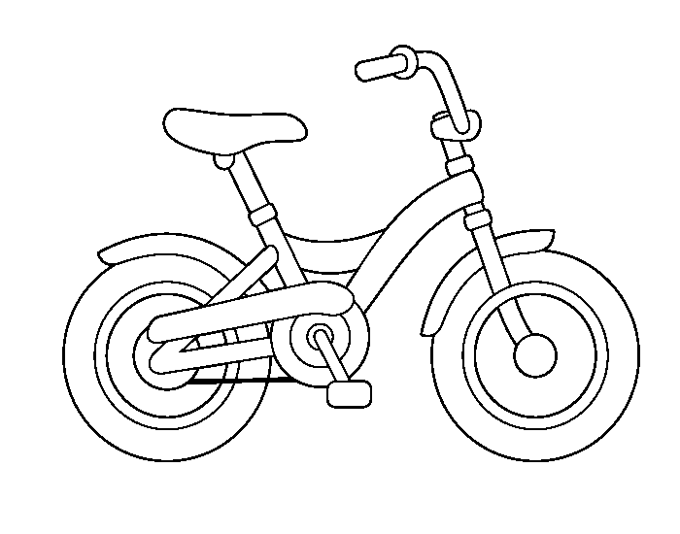

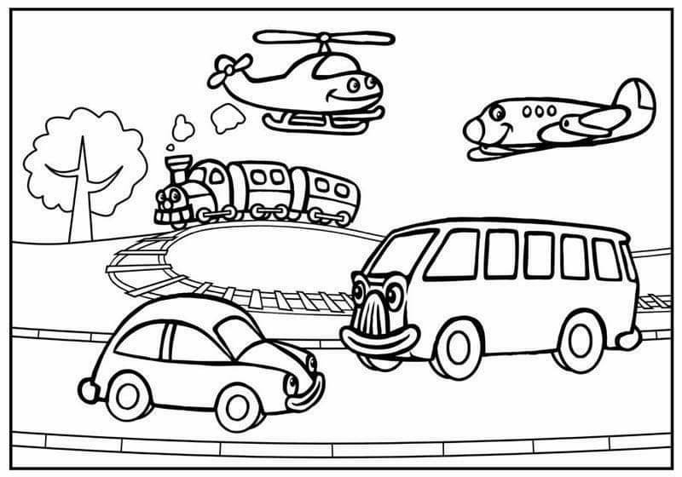

I invite you to learn new emotions vocabulary zapraszam do nauki nowych wyrazów o emocjach.

My Happy Song – Moja szczęśliwa piosenka.

https://www.youtube.com/watch?time_continue=236&v=ufbOHl1mmYk&feature=emb_title

This is my happy song.
To jest moja szczęśliwa piosenka.
I like to sing it all day long.
Lubię śpiewać to przez cały dzień.
I’ll teach you the words.
Nauczę cię słów.
Then you can sing along.
Potem możesz śpiewać.

Happy, happy, happy.
Szczęśliwy, szczęśliwy, szczęśliwy.
Happy, happy, happy, happy, happy.
Happy, happy, happy, happy, happy, happy, happy, happy.
Happy, happy, happy, happy, happy.

Great! Let’s try it again!
Świetny! Spróbujmy jeszcze raz!

This is my happy song.
I like to sing it all day long.
I’ll teach you the words.
Then you can sing along.

Let’s try a high voice.
Spróbujmy wysokiego głosu.

Happy, happy, happy.
Happy, happy, happy, happy, happy.
Happy, happy, happy, happy, happy, happy, happy, happy.
Happy, happy, happy, happy, happy.

Nice job!
Dobra robota!

This is my happy song.
I like to sing it all day long.
I’ll teach you the words.
Then you can sing along.

Let’s try a LOW voice!
Wypróbujmy NISKI głos!

Happy, happy, happy.
Happy, happy, happy, happy, happy.
Happy, happy, happy, happy, happy, happy, happy, happy..
Happy, happy, happy, happy, happy.

Great! Let’s sing it again!
Świetnie! Zaśpiewajmy to jeszcze raz!

This is my happy song.
I like to sing it all day long.
I’ll teach you the words.
Then you can sing along.

Let’s sing it underwater.
Zaśpiewajmy to pod wodą.

Happy, happy, happy.
Happy, happy, happy, happy, happy.
Happy, happy, happy, happy, happy, happy, happy, happy..
Happy, happy, happy, happy, happy.

Here we go again!
Znowu zaczynamy!

This is my happy song.
I like to sing it all day long.
I’ll teach you the words.
Then you can sing along.

Let’s sing it fast!
Zaśpiewajmy to szybko!

Happy, happy, happy.
Happy, happy, happy, happy, happy.
Happy, happy, happy, happy, happy, happy, happy, happy.
Happy, happy, happy, happy, happy.

Faster?!
Szybciej?!

Happy, happy, happy.
Happy, happy, happy, happy, happy.
Happy, happy, happy, happy, happy, happy, happy, happy.
Happy, happy, happy, happy, happy.

This is my happy song!
To moja szczęśliwa piosenka!

If you’re happy – Jeśli jesteś szczęśliwy

https://supersimple.com/song/if-youre-happy/

If you’re happy happy happy, clap your hands.
Jeśli jesteś szczęśliwy, szczęśliwy, klaszcz w dłonie.
If you’re happy happy happy, clap your hands.
If you’re happy happy happy, clap your hands, clap your hands.
If you’re happy happy happy, clap your hands.

If you’re angry angry angry, stomp your feet.
Jeśli jesteś zły, zły, tupnij nogą.
If you’re angry angry angry, stomp your feet.
If you’re angry angry angry, stomp your feet, stomp your feet.
If you’re angry angry angry, stomp your feet.

If you’re scared scared scared, say, “Oh no!”
Jeśli się boisz, boisz się, mów: „Och nie!”
If you’re scared scared scared, say, “Oh no!”
If you’re scared scared scared, say, “Oh no!” Say, “Oh no!”
If you’re scared scared scared, say, “Oh no!”

If you’re sleepy sleepy sleepy, take a nap.
Jeśli jesteś śpiący śpiący śpiący, zdrzemnij się.
If you’re sleepy sleepy sleepy, take a nap.
If you’re sleepy sleepy sleepy, take a nap, take a nap.
If you’re sleepy sleepy sleepy, take a nap.

If you’re happy happy happy, clap your hands.
Jeśli jesteś szczęśliwy, szczęśliwy, klaszcz w dłonie.
If you’re happy happy happy, clap your hands.
If you’re happy happy happy, clap your hands, clap your hands.
If you’re happy happy happy, clap your hands.

Below are pictures of emotions whose names we got to know in the songs. – poniżej znajdują się obrazki emocji których nazwy poznaliśmy w piosenkach.
If you want you can color it , -jeśli chcesz możesz je pokolorować.

I have a request if you use the materials and are useful for your children please provide feedback on Facebook (under the post – like, emote or photo)- Mam prośbę jeśli korzystacie z materiałów i są dla Państwa dzieci przydatne proszę o informacje zwrotną (pod postem - like, emotka, zdjęcie)
Thank you -Dziękuję
Magdalena Marnik-Szajter

If You're Happy | My name is
From Super Simple Songs - One

Color.+

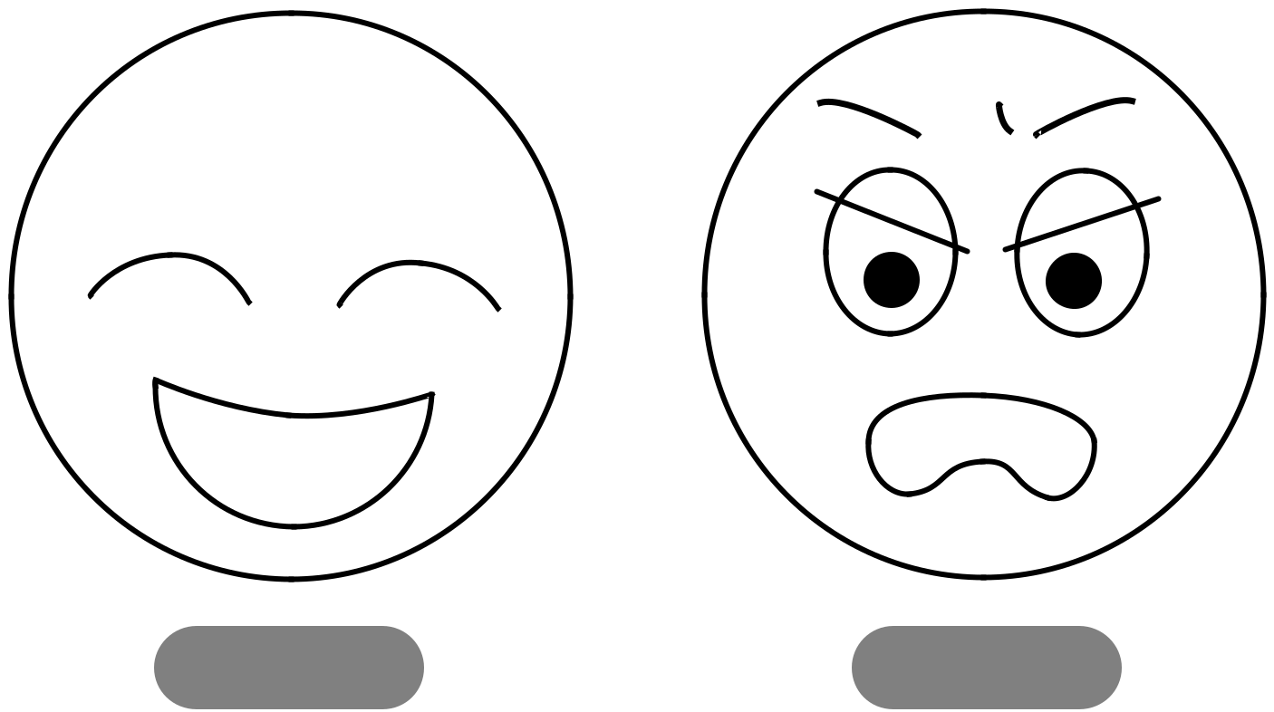

happy angry

^{Z}Z_{Z}
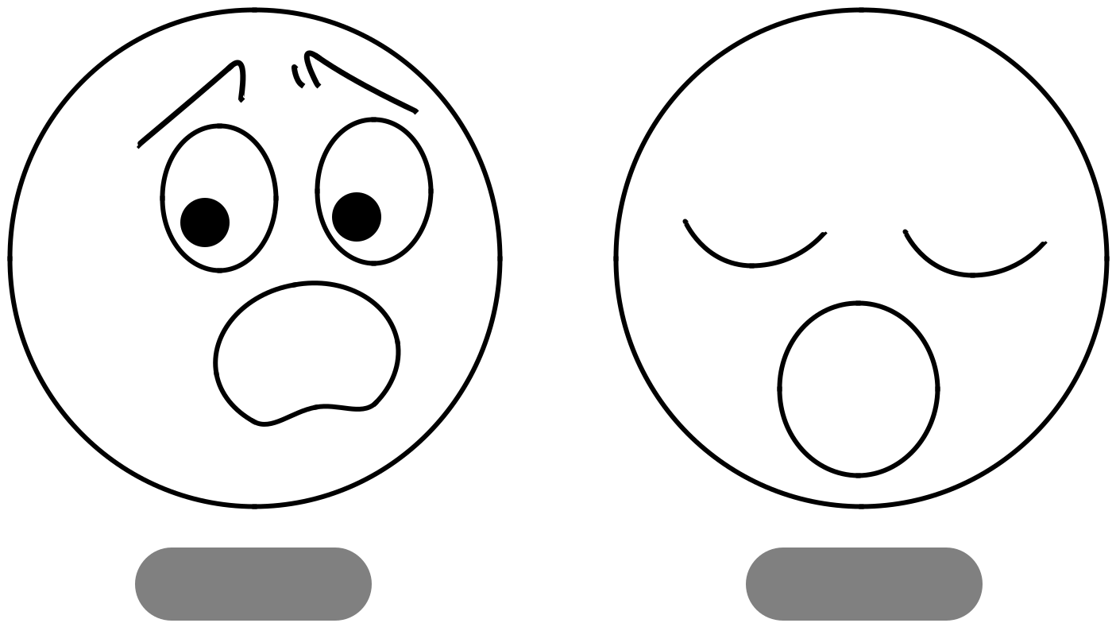

If You're Happy | My name is
