English – Język angielski 4

Hello everyone – Witam wszystkich 😊

Repeat the song “What is it” – Powtórzcie piosenkę “Co to jest?”
https://www.youtube.com/watch?v=i73uGD9xlEk

Now I invite you to learn a new songs „Bingo” and „Old MacDonald has a farm” - Teraz zapraszam chętnych do nauki nowych piosenk „Bingo” i “Stary MacDonald farmę miał”
We consolidate vocabulary related to animals living on the farm this time.
Utrwalamy słownictwo związane ze zwierzętami tym razem żyjącymi na farmie.

https://www.youtube.com/watch?time_continue=1&v=9mmF8zOlh_g&feature=emb_title
There was a farmer had a dog – był tam Rolnik , miał psa
and Bingo was his name-o. – i miał na imię BINGO (pies)
B-I-N-G-O
B-I-N-G-O
B-I-N-G-O
And Bingo was his name-o. – I miał na imię Bingo (pies).
Clap! – klaskać!
There was a farmer had a dog
and Bingo was his name-o.
*-I-N-G-O
*-I-N-G-O
*-I-N-G-O
And Bingo was his name-o.
Pat your legs! – poklepuj nogi!
There was a farmer had a dog
and Bingo was his name-o.
*-*-N-G-O
*-*-N-G-O
*-*-N-G-O
And Bingo was his name-o.
Pat your tummy! – poklep swój brzuch!
There was a farmer had a dog
and Bingo was his name-o.
*-*-*-G-O
*-*-*-G-O
*-*-*-G-O
And Bingo was his name-o.
Pat your head! – poklep sie po głowie!
There was a farmer had a dog
and Bingo was his name-o.
*-*-*-*-O
*-*-*-*-O
*-*-*-*-O
And Bingo was his name-o.
Jump! – skacz!
There was a farmer had a dog
and Bingo was his name-o.
*-*-*-*-*
*-*-*-*-*
*-*-*-*-*
And Bingo was his name-o.
B-I-N-G-O
B-I-N-G-O
B-I-N-G-O
And Bingo was his name-o.

Old MacDonald had a farm – Stary MacDonald farmę miał.
https://www.youtube.com/watch?time_continue=197&v=_6HzoUcx3eo&feature=emb_title

Old MacDonald had a farm. E-I-E-I-O. - Stary MacDonald farmę miał.
And on that farm he had a pig. E-I-E-I-O. – I na tej farmie miał świnię
With an oink oink here. – pochrząkiwanie tutaj
And an oink oink there. – i tam pochrząkiwanie
Here an oink.- tu pochrząkiwanie
There an oink. – tam pochrząkiwanie
Everywhere an oink oink. – wszędzie pochrząkiwanie.
Old MacDonald had a farm. E-I-E-I-O. - Stary MacDonald farmę miał.
Old MacDonald had a farm. E-I-E-I-O.
And on that farm he had a duck. E-I-E-I-O. – i na tej farmie miał kaczke
With a quack quack here.
And a quack quack there.
And an oink oink here.
And an oink oink there.
Old MacDonald had a farm. E-I-E-I-O.
Old MacDonald had a farm. E-I-E-I-O.
And on that farm he had a horse. E-I-E-I-O. – i na tej farmie miał konia
With a neigh neigh here.
And a neigh neigh there.
And a quack quack here.
And a quack quack there.
And an oink oink here.
And an oink oink there.
Old MacDonald had a farm. E-I-E-I-O.
Old MacDonald had a farm. E-I-E-I-O.
And on that farm he had a sheep. E-I-E-I-O. – I na tej farmie miał owce
With a baaa baaa here.
And a baaa baaa there.
And a neigh neigh here.
And a neigh neigh there.
And a quack quack here.
And a quack quack there.
And an oink oink here.
And an oink oink there.
Old MacDonald had a farm. E-I-E-I-O.
Old MacDonald had a farm. E-I-E-I-O.
And on that farm he had a cow. E-I-E-I-O. – I na tej farmie miał krowe
With a moo moo here.
And a moo moo there.
And a baaa baaa here.
And a baaa baaa there.
And a neigh neigh here.
And a neigh neigh there.
And a quack quack here.
And a quack quack there.
And an oink oink here.
And an oink oink there.
Old MacDonald had a farm. E-I-E-I-O.
Old MacDonald had a farm. E-I-E-I-O.
And on that farm he had a turkey. E-I-E-I-O. – I na tej farmie miał indyka
With a gobble-gobble here,
And a gobble-gobble there,
And a moo moo here.
And a moo moo there.
And a baaa baaa here.
And a baaa baaa there.
And a neigh neigh here.
And a neigh neigh there.
And a quack quack here.
And a quack quack there.
And an oink oink here.
And an oink oink there.
Old MacDonald had a farm. E-I-E-I-O.
E-I-E-I-O.

Proposition of movement and drawing games - Propozycja zabaw ruchowych i rysunkowych:
- move like a listed animal - poruszaj się jak wymienione zwierzę:
    - cat - kot
    - dog - pies
    - cow - krowa
    - horse - koń
    - hen - kura
    - rooster - kogut
    - pig - świnka
    - sheep - owca
    - turkey- indyk

- imitate the sounds made by following animal - naśladuj odgłosy wydawane przez wymienione zwierzę :
    - kot
    - pies
    - krowa
    - koń
    - kura
    - kogut
    - świnka
    - owca
    - indyk

- draw any animal e.g. - narysuj dowolne zwierzę np.:
- kot
- pies
- krowa
- koń
- kura
- kogut
- świnka
- owca
- indyk.

If you want you can print out and colour pictures now– Jeśli chcesz teraz możesz wydrukować i pokolorować obrazki.

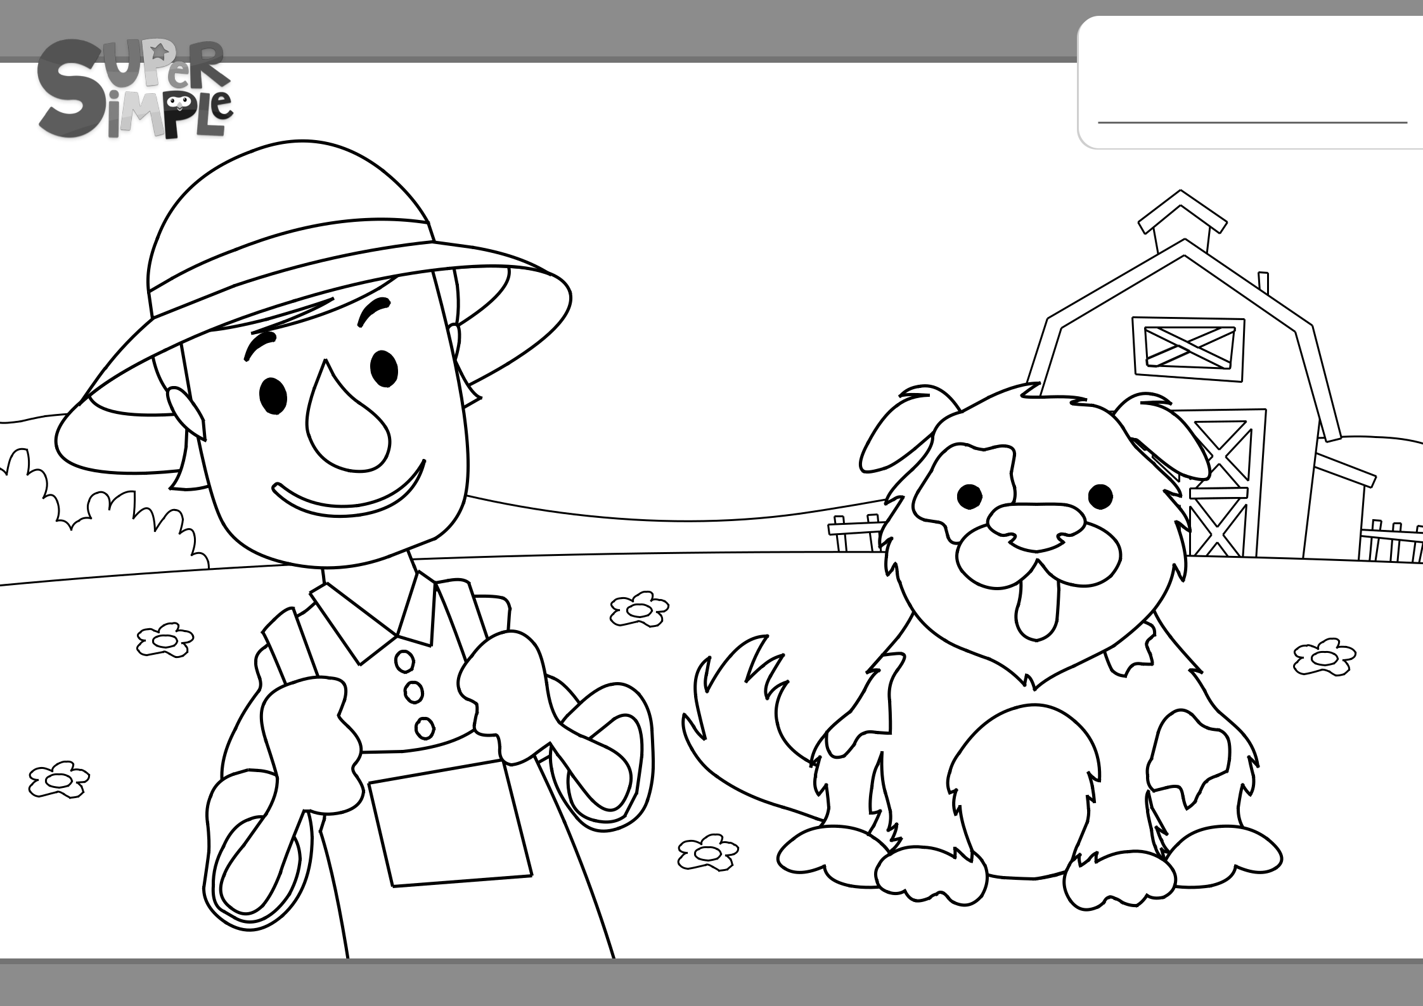
BINGO

My name is

Get more coloring pages from www.supersimplelearning.com

1 of 4

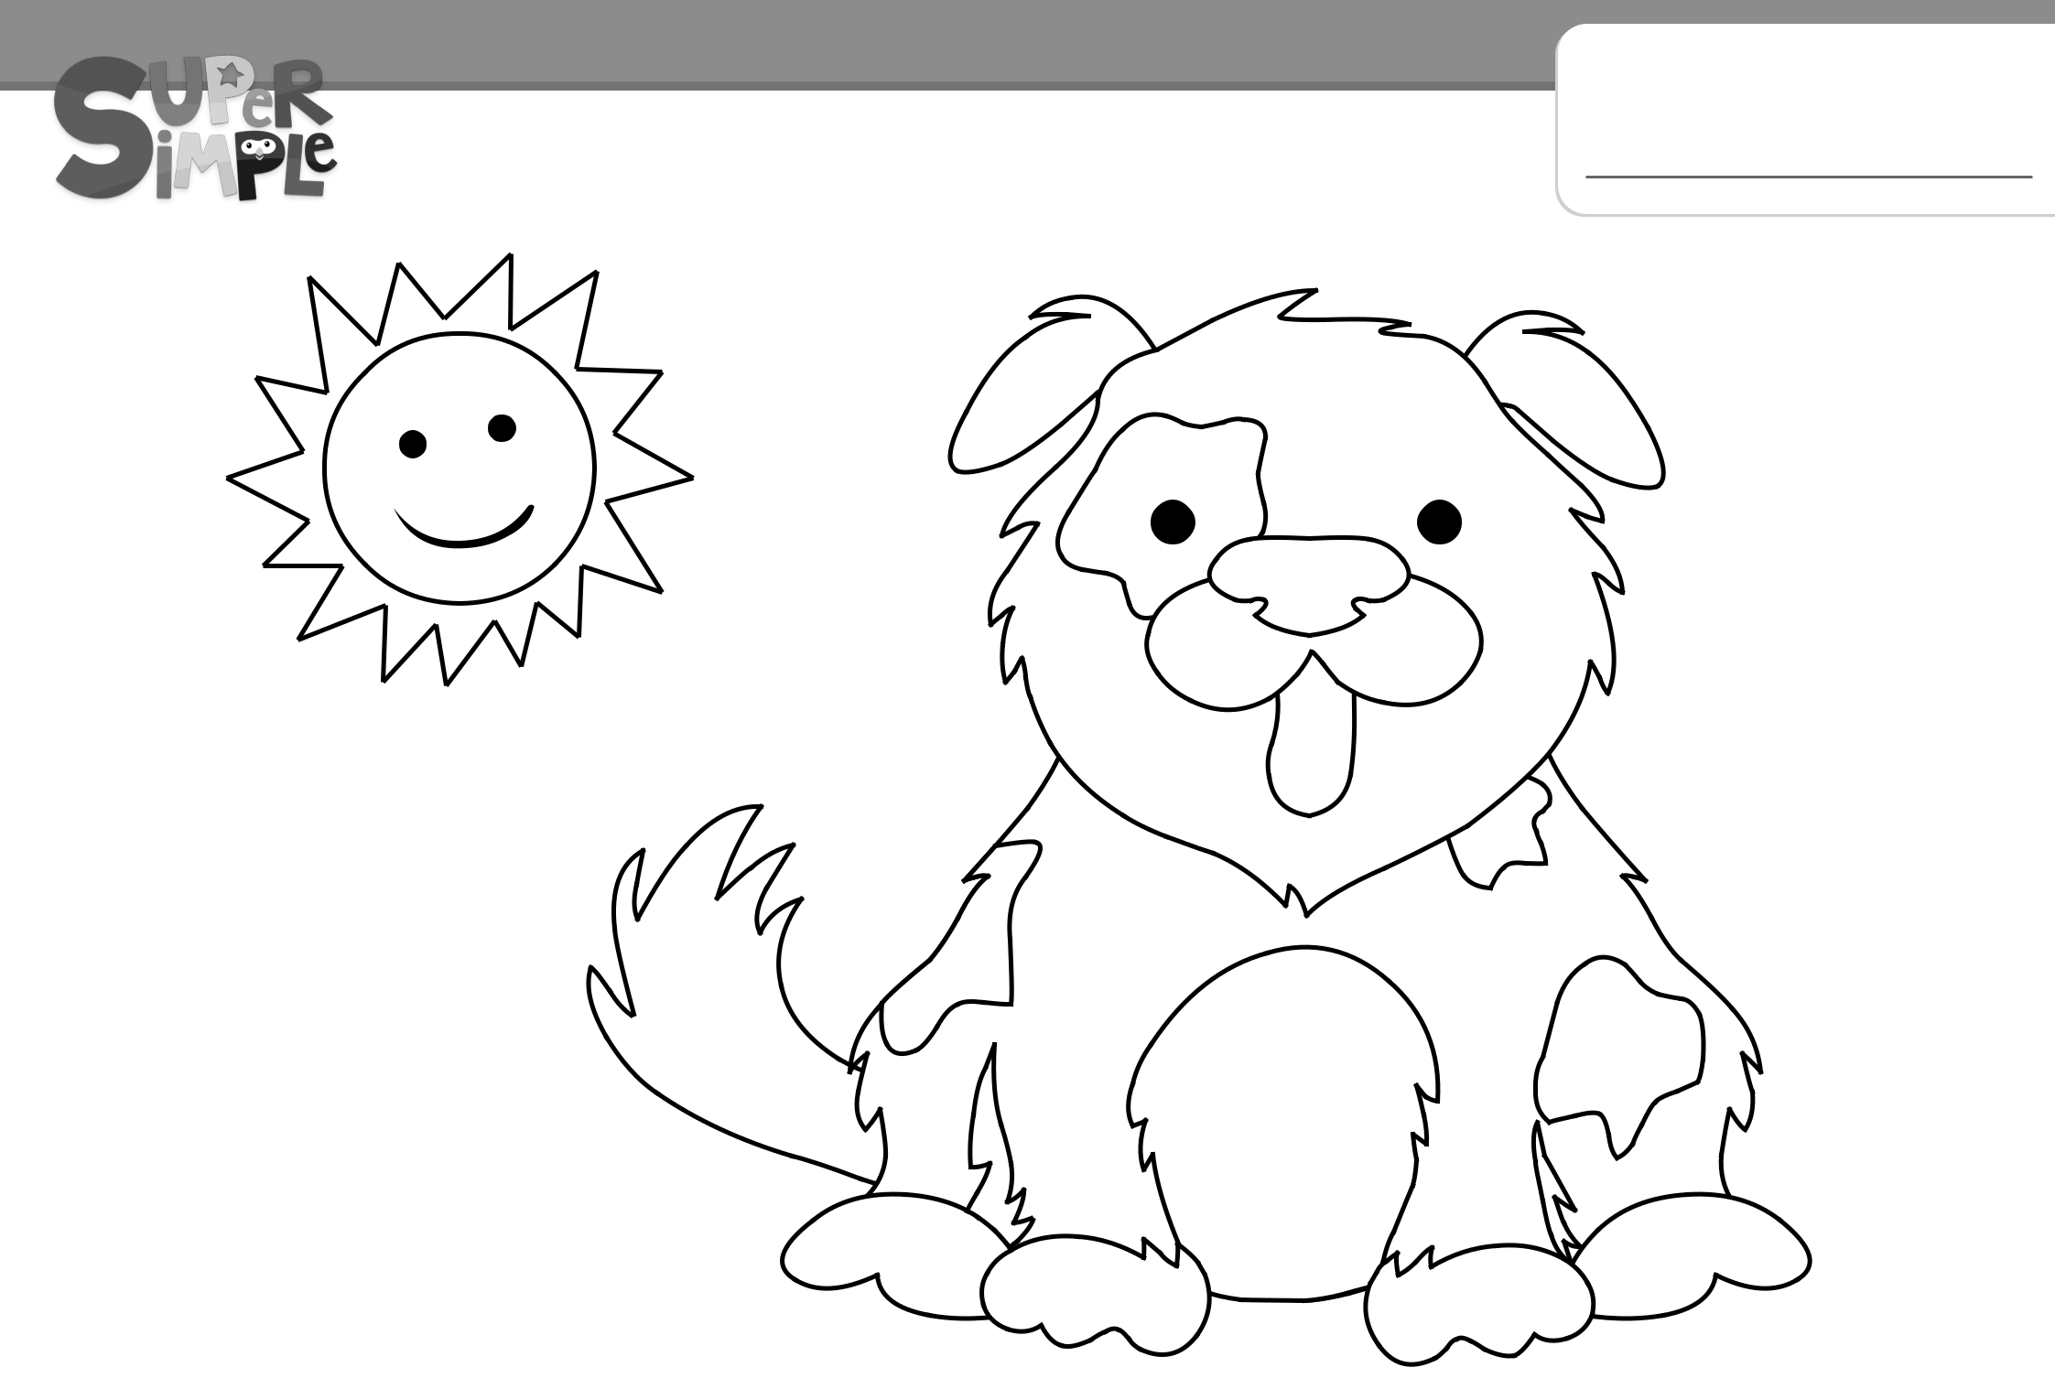
BINGO

My name is

Get more coloring pages from www.supersimplelearning.com

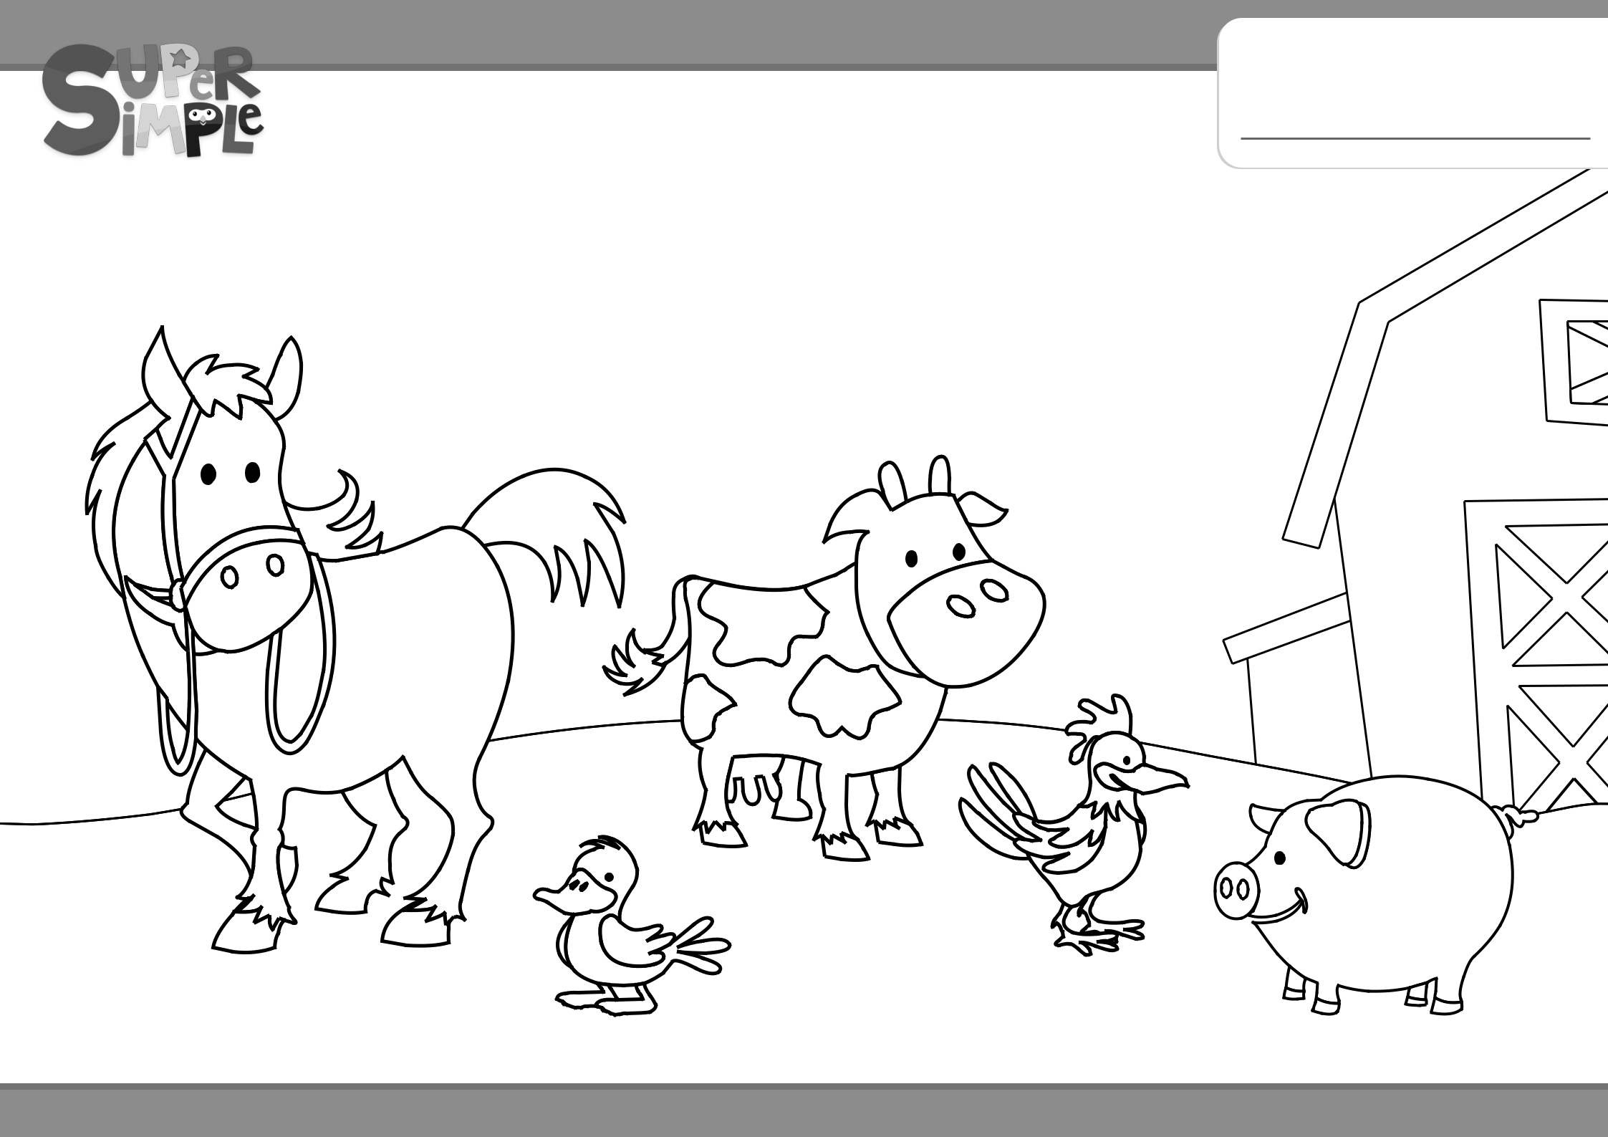
BINGO

My name is

Get more coloring pages from www.supersimplelearning.com

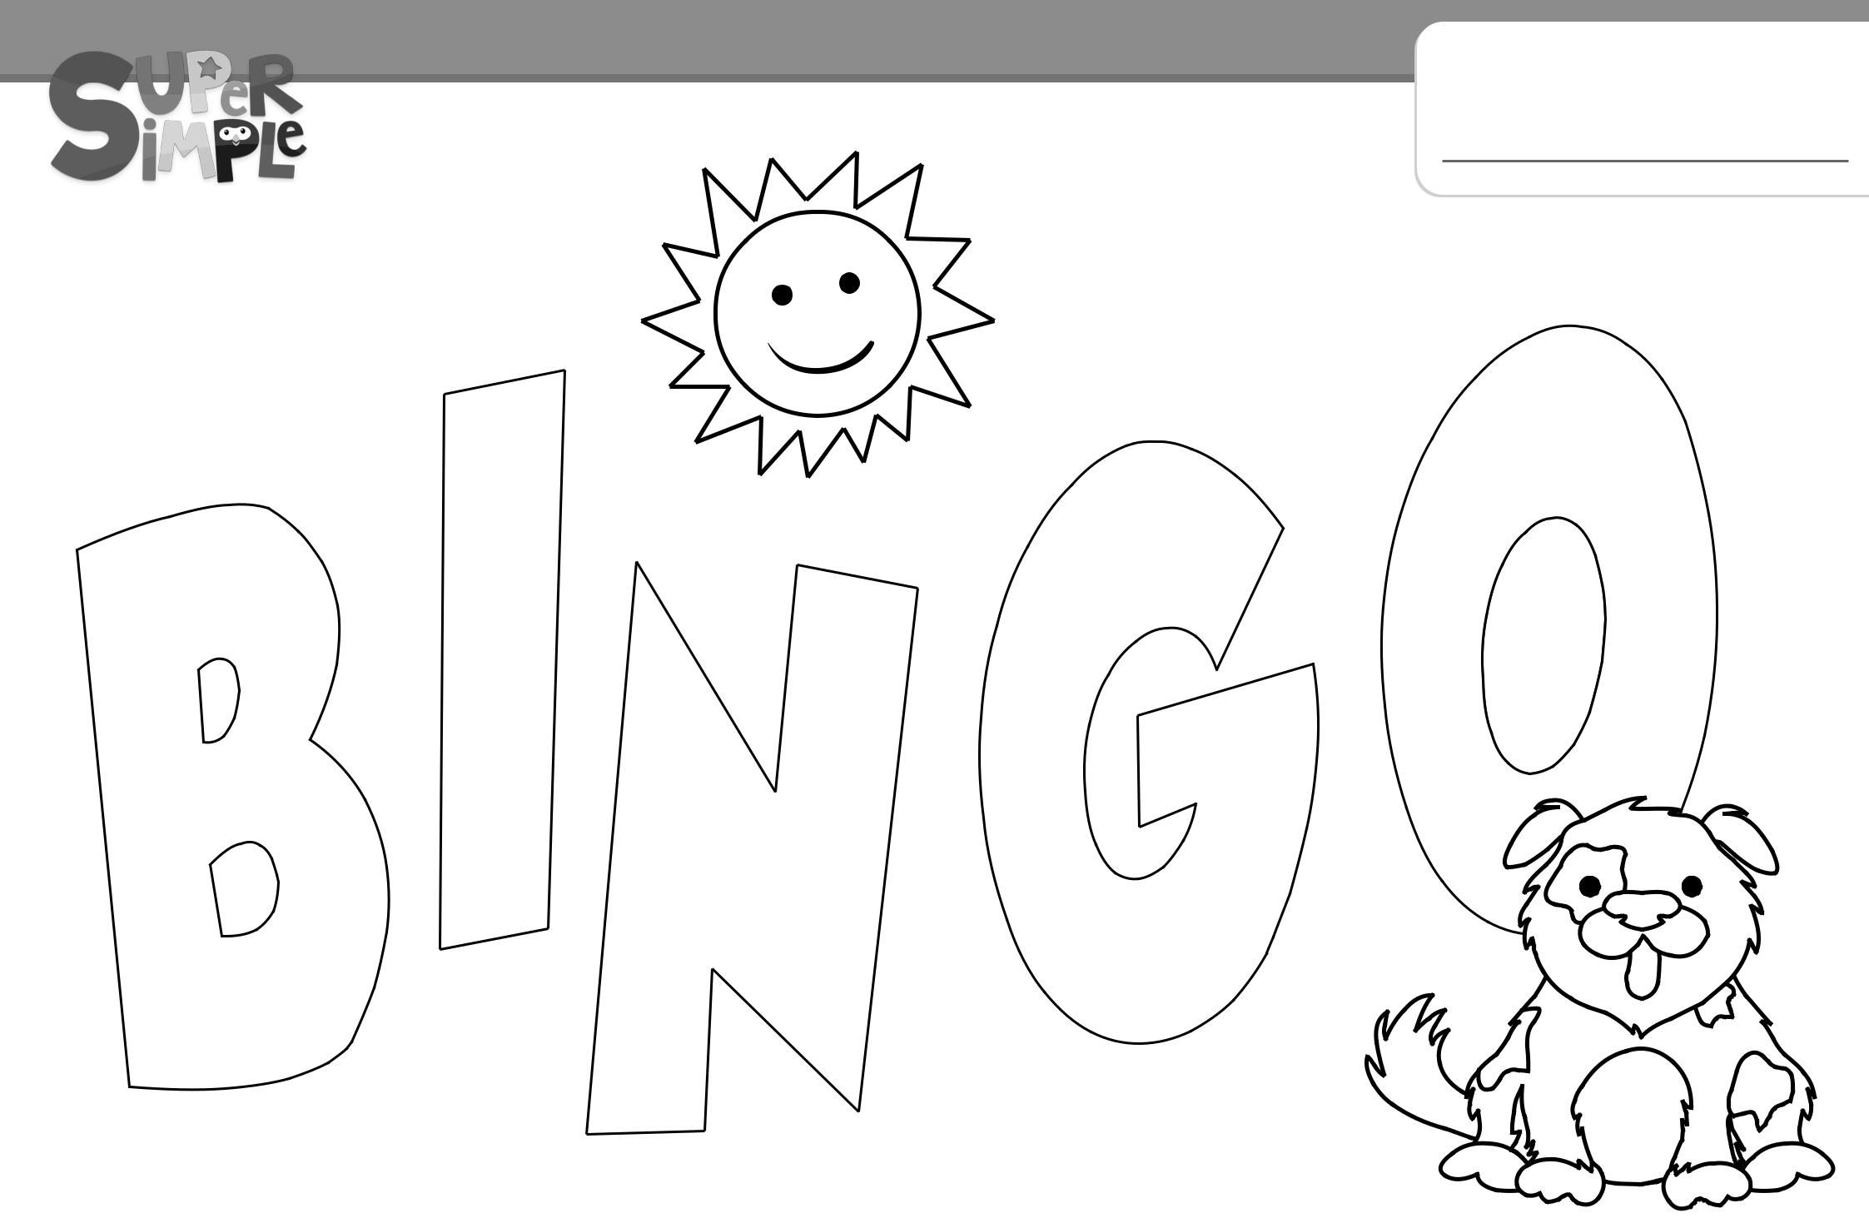
BINGO

My
Have fun - Miłej zabawy. 😊

